## Module 2 Assignment 2

### Nicholas Barrett, 02/02/19

library(tidyverse)

## -- Attaching packages ---------------------- tidyverse 1.2.1 --

## v ggplot2 3.1.0 v purrr 0.2.5  
## v tibble 1.4.2 v dplyr 0.7.7  
## v tidyr 0.8.2 v stringr 1.3.1  
## v readr 1.1.1 v forcats 0.3.0

## -- Conflicts ------------------------- tidyverse_conflicts() --  
## x dplyr::filter() masks stats::filter()  
## x dplyr::lag() masks stats::lag()

library(GGally)

## Warning: package 'GGally' was built under R version 3.5.2

##   
## Attaching package: 'GGally'

## The following object is masked from 'package:dplyr':  
##   
## nasa

library(MASS)

##   
## Attaching package: 'MASS'

## The following object is masked from 'package:dplyr':  
##   
## select

library(leaps)

## Warning: package 'leaps' was built under R version 3.5.2

### Task 1 - Read in the “hour.csv” file into a data frame named “bike”. Complete the variable conversions and recoding.

bike = read_csv("hours.csv")

## Parsed with column specification:  
## cols(  
## instant = col_integer(),  
## dteday = col_character(),  
## season = col_integer(),  
## yr = col_integer(),  
## mnth = col_integer(),  
## hr = col_integer(),  
## holiday = col_integer(),  
## weekday = col_integer(),  
## workingday = col_integer(),  
## weathersit = col_integer(),  
## temp = col_double(),  
## atemp = col_double(),  
## hum = col_double(),  
## windspeed = col_double(),  
## casual = col_integer(),  
## registered = col_integer(),  
## count = col_integer()  
## )

Convert “season” variable to factor and rename to be more descriptive.

bike <- bike %>% mutate(season = as_factor(as.character(season))) %>%  
 mutate(season = fct_recode(season, "Spring" = "1", "Summer" = "2", "Fall" = "3", "Winter" = "4"))

Convert “yr”, “mnth”, and “hr” to factors.

bike <- bike %>% mutate(yr = as_factor(as.character(yr)))

bike <- bike %>% mutate(mnth = as_factor(as.character(mnth)))

bike <- bike %>% mutate(hr = as_factor(as.character(hr)))

str(bike)

## Classes 'tbl_df', 'tbl' and 'data.frame': 17379 obs. of 17 variables:  
## $ instant : int 1 2 3 4 5 6 7 8 9 10 ...  
## $ dteday : chr "1/1/2011" "1/1/2011" "1/1/2011" "1/1/2011" ...  
## $ season : Factor w/ 4 levels "Spring","Summer",..: 1 1 1 1 1 1 1 1 1 1 ...  
## $ yr : Factor w/ 2 levels "0","1": 1 1 1 1 1 1 1 1 1 1 ...  
## $ mnth : Factor w/ 12 levels "1","2","3","4",..: 1 1 1 1 1 1 1 1 1 1 ...  
## $ hr : Factor w/ 24 levels "0","1","2","3",..: 1 2 3 4 5 6 7 8 9 10 ...  
## $ holiday : int 0 0 0 0 0 0 0 0 0 0 ...  
## $ weekday : int 6 6 6 6 6 6 6 6 6 6 ...  
## $ workingday: int 0 0 0 0 0 0 0 0 0 0 ...  
## $ weathersit: int 1 1 1 1 1 2 1 1 1 1 ...  
## $ temp : num 0.24 0.22 0.22 0.24 0.24 0.24 0.22 0.2 0.24 0.32 ...  
## $ atemp : num 0.288 0.273 0.273 0.288 0.288 ...  
## $ hum : num 0.81 0.8 0.8 0.75 0.75 0.75 0.8 0.86 0.75 0.76 ...  
## $ windspeed : num 0 0 0 0 0 0.0896 0 0 0 0 ...  
## $ casual : int 3 8 5 3 0 0 2 1 1 8 ...  
## $ registered: int 13 32 27 10 1 1 0 2 7 6 ...  
## $ count : int 16 40 32 13 1 1 2 3 8 14 ...

Convert the “holiday” variable to a factor and recode the level of the factors.

bike <- bike %>% mutate(holiday = as_factor(as.character(holiday))) %>%  
 mutate(holiday = fct_recode(holiday, "NotHoliday" = "0", "Holiday" = "1"))

Convert the “workingday” variable to a factor and recode the level of the factors.

bike <- bike %>% mutate(workingday = as_factor(as.character(workingday))) %>%  
 mutate(workingday = fct_recode(workingday, "NotWorkingDay" = "0", "WorkingDay" = "1"))

Convert the “weathersit” variable to a factor and recode the level of the factors.

bike <- bike %>% mutate(weathersit = as_factor(as.character(weathersit))) %>%  
 mutate(weathersit = fct_recode(weathersit, "NoPrecip" = "1", "Misty" = "2", "LightPrecip" = "3", "HeavyPrecip" = "4"))

Convert the “weekday” variable to a factor and recode the level of the factors.

bike <- bike %>% mutate(weekday = as_factor(as.character(weekday))) %>%  
 mutate(weekday = fct_recode(weekday, "Saturday" = "6", "Sunday" = "0", "Monday" = "1", "Tuesday" = "2", "Wednesday" = "3", "Thursday" = "4", "Friday" = "5"))

str(bike)

## Classes 'tbl_df', 'tbl' and 'data.frame': 17379 obs. of 17 variables:  
## $ instant : int 1 2 3 4 5 6 7 8 9 10 ...  
## $ dteday : chr "1/1/2011" "1/1/2011" "1/1/2011" "1/1/2011" ...  
## $ season : Factor w/ 4 levels "Spring","Summer",..: 1 1 1 1 1 1 1 1 1 1 ...  
## $ yr : Factor w/ 2 levels "0","1": 1 1 1 1 1 1 1 1 1 1 ...  
## $ mnth : Factor w/ 12 levels "1","2","3","4",..: 1 1 1 1 1 1 1 1 1 1 ...  
## $ hr : Factor w/ 24 levels "0","1","2","3",..: 1 2 3 4 5 6 7 8 9 10 ...  
## $ holiday : Factor w/ 2 levels "NotHoliday","Holiday": 1 1 1 1 1 1 1 1 1 1 ...  
## $ weekday : Factor w/ 7 levels "Saturday","Sunday",..: 1 1 1 1 1 1 1 1 1 1 ...  
## $ workingday: Factor w/ 2 levels "NotWorkingDay",..: 1 1 1 1 1 1 1 1 1 1 ...  
## $ weathersit: Factor w/ 4 levels "NoPrecip","Misty",..: 1 1 1 1 1 2 1 1 1 1 ...  
## $ temp : num 0.24 0.22 0.22 0.24 0.24 0.24 0.22 0.2 0.24 0.32 ...  
## $ atemp : num 0.288 0.273 0.273 0.288 0.288 ...  
## $ hum : num 0.81 0.8 0.8 0.75 0.75 0.75 0.8 0.86 0.75 0.76 ...  
## $ windspeed : num 0 0 0 0 0 0.0896 0 0 0 0 ...  
## $ casual : int 3 8 5 3 0 0 2 1 1 8 ...  
## $ registered: int 13 32 27 10 1 1 0 2 7 6 ...  
## $ count : int 16 40 32 13 1 1 2 3 8 14 ...

Why do we convert “yr”, “mnth”, and “hr” into factors? Why not just leave them as numbers? Converting numbers to factors allows these variables to become binary dummy variables. Making this change helps handle various levels within these variables.

### Task 2 - Which of the quantitative variables appears to be best correlated with “count” - ignoring “registered” and “count” variables as the sume of these equals “count”.

ggcorr(bike, label = TRUE)

## Warning in ggcorr(bike, label = TRUE): data in column(s) 'dteday',  
## 'season', 'yr', 'mnth', 'hr', 'holiday', 'weekday', 'workingday',  
## 'weathersit' are not numeric and were ignored

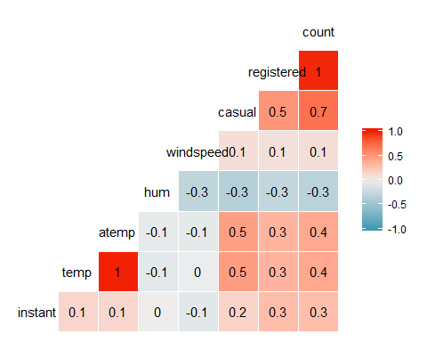

From the chart above, it appears that “temp” is the best correlated variable to the “count”.

### Task 3 - Complete a boxplot-based analysis for each categorical variable: Season, Yr, Mnth, Holiday, WorkingDay, Weathersit, and weekday. Explain why each does or does not affect count.

ggplot(bike,aes(x = hr, y = count)) + geom_boxplot()

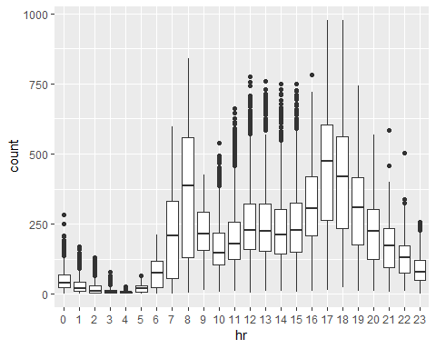 Hour of the day appears to have a significant impact on the number of bike rides - evidenced by the increased number of rides during daylight hours.

ggplot(bike,aes(x = season, y = count)) + geom_boxplot()

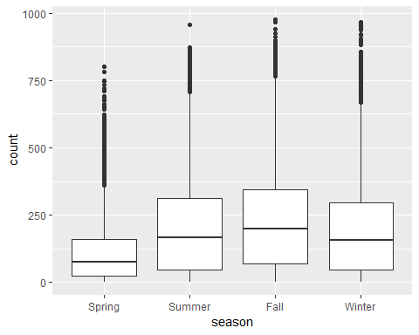

Seasons do not appears to have a significant impact on the count of rides. The median count for each season are very close.

ggplot(bike,aes(x = yr, y = count)) + geom_boxplot()

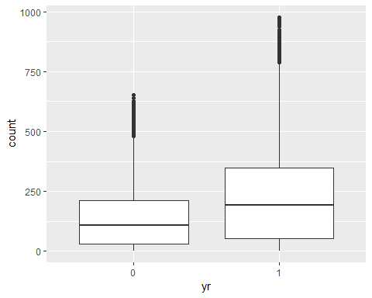

Year does not appear to have a significant impact on the count.

ggplot(bike,aes(x = mnth, y = count)) + geom_boxplot()

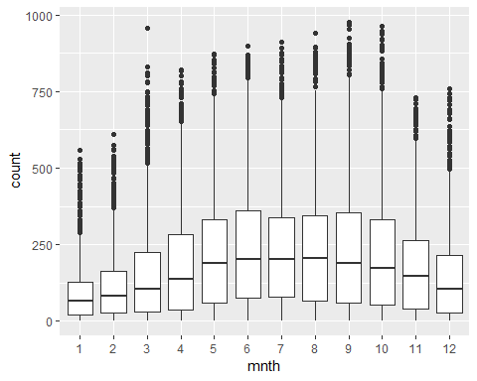

Month appears to have a significant relationship to the number of rides that appears to grow during warmer months.

ggplot(bike,aes(x = holiday, y = count)) + geom_boxplot()

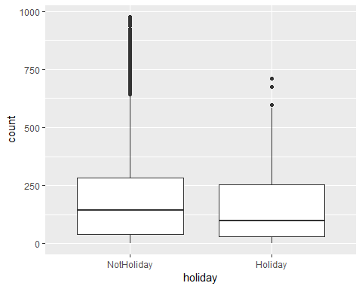

Holidays versus non-holidays does not appear to have a significant relationship with the number of rides. However, there are more outliers outside of the 3rd Quartile during NotHoliday times.

ggplot(bike,aes(x = workingday, y = count)) + geom_boxplot()

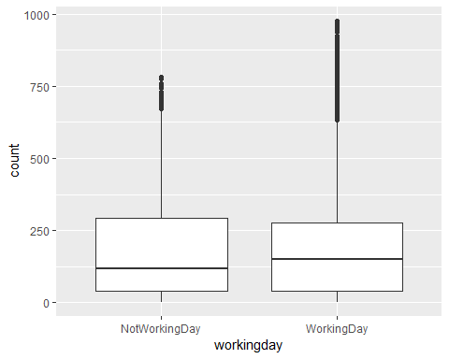

Working day does not appear to have a significant impact on bike ride counts.

ggplot(bike,aes(x = weathersit, y = count)) + geom_boxplot()

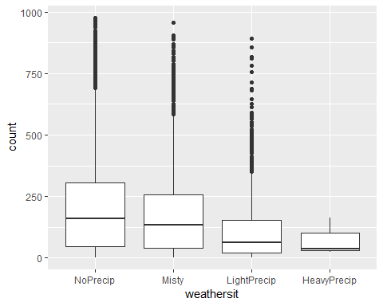

The weather situation appears to have a significance on the number of bike rides. Days with light or heavy rain had far fewer rides than misty or no precip days.

ggplot(bike,aes(x = weekday, y = count)) + geom_boxplot()

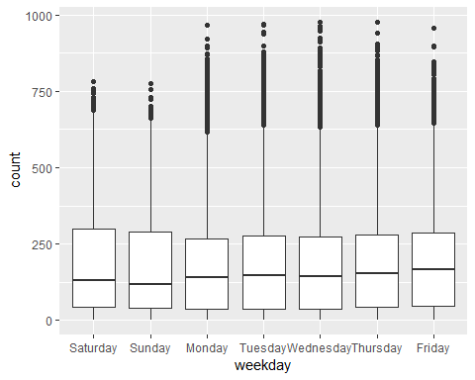

Day of the week appears to have no significance in the count of bike rides. The 1-3 quartile ranges are practically the same.

### Task 4 - Use forward stepwise regression to build a multiple linear regression model to predict “count”.

bike2 = bike %>% dplyr::select(-c(instant, dteday, registered, casual))

bike2 = bike2 %>% mutate(yr = as.integer (yr)-1)  
glimpse(bike2)

## Observations: 17,379  
## Variables: 13  
## $ season <fct> Spring, Spring, Spring, Spring, Spring, Spring, Spr...  
## $ yr <dbl> 0, 0, 0, 0, 0, 0, 0, 0, 0, 0, 0, 0, 0, 0, 0, 0, 0, ...  
## $ mnth <fct> 1, 1, 1, 1, 1, 1, 1, 1, 1, 1, 1, 1, 1, 1, 1, 1, 1, ...  
## $ hr <fct> 0, 1, 2, 3, 4, 5, 6, 7, 8, 9, 10, 11, 12, 13, 14, 1...  
## $ holiday <fct> NotHoliday, NotHoliday, NotHoliday, NotHoliday, Not...  
## $ weekday <fct> Saturday, Saturday, Saturday, Saturday, Saturday, S...  
## $ workingday <fct> NotWorkingDay, NotWorkingDay, NotWorkingDay, NotWor...  
## $ weathersit <fct> NoPrecip, NoPrecip, NoPrecip, NoPrecip, NoPrecip, M...  
## $ temp <dbl> 0.24, 0.22, 0.22, 0.24, 0.24, 0.24, 0.22, 0.20, 0.2...  
## $ atemp <dbl> 0.2879, 0.2727, 0.2727, 0.2879, 0.2879, 0.2576, 0.2...  
## $ hum <dbl> 0.81, 0.80, 0.80, 0.75, 0.75, 0.75, 0.80, 0.86, 0.7...  
## $ windspeed <dbl> 0.0000, 0.0000, 0.0000, 0.0000, 0.0000, 0.0896, 0.0...  
## $ count <int> 16, 40, 32, 13, 1, 1, 2, 3, 8, 14, 36, 56, 84, 94, ...

ggcorr(bike2, label = TRUE)

## Warning in ggcorr(bike2, label = TRUE): data in column(s) 'season', 'mnth',  
## 'hr', 'holiday', 'weekday', 'workingday', 'weathersit' are not numeric and  
## were ignored

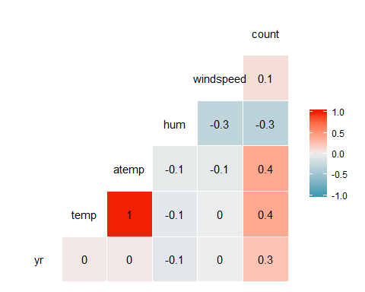

mod1 <- lm(count ~ temp, bike2)  
summary(mod1)

##   
## Call:  
## lm(formula = count ~ temp, data = bike2)  
##   
## Residuals:  
## Min 1Q Median 3Q Max   
## -291.37 -110.23 -32.86 76.77 744.76   
##   
## Coefficients:  
## Estimate Std. Error t value Pr(>|t|)   
## (Intercept) -0.0356 3.4827 -0.01 0.992   
## temp 381.2949 6.5344 58.35 <2e-16 ***  
## ---  
## Signif. codes: 0 '***' 0.001 '**' 0.01 '*' 0.05 '.' 0.1 ' ' 1  
##   
## Residual standard error: 165.9 on 17377 degrees of freedom  
## Multiple R-squared: 0.1638, Adjusted R-squared: 0.1638   
## F-statistic: 3405 on 1 and 17377 DF, p-value: < 2.2e-16

ggplot(bike2, aes(x=temp, y=count)) + geom_point() +  
geom_smooth(method = lm, se = FALSE) + theme_bw()

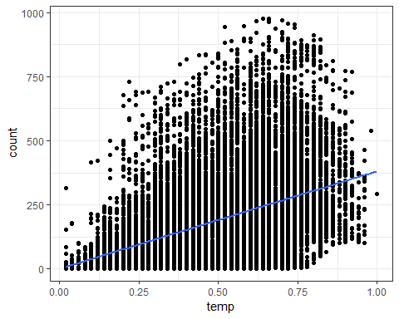

mod1 <- lm(count ~ atemp, bike2)  
summary(mod1)

##   
## Call:  
## lm(formula = count ~ atemp, data = bike2)  
##   
## Residuals:  
## Min 1Q Median 3Q Max   
## -314.55 -110.95 -33.25 77.70 743.29   
##   
## Coefficients:  
## Estimate Std. Error t value Pr(>|t|)   
## (Intercept) -11.876 3.711 -3.20 0.00137 **   
## atemp 423.180 7.335 57.69 < 2e-16 ***  
## ---  
## Signif. codes: 0 '***' 0.001 '**' 0.01 '*' 0.05 '.' 0.1 ' ' 1  
##   
## Residual standard error: 166.2 on 17377 degrees of freedom  
## Multiple R-squared: 0.1607, Adjusted R-squared: 0.1607   
## F-statistic: 3328 on 1 and 17377 DF, p-value: < 2.2e-16

ggplot(bike2, aes(x=atemp, y=count)) + geom_point() +  
geom_smooth(method = lm, se = FALSE) + theme_bw()

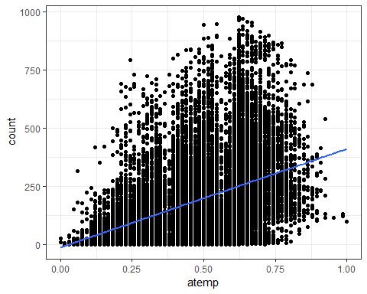

allmod = lm(count ~., bike2)   
summary(allmod)

##   
## Call:  
## lm(formula = count ~ ., data = bike2)  
##   
## Residuals:  
## Min 1Q Median 3Q Max   
## -393.87 -60.66 -7.96 51.31 439.18   
##   
## Coefficients: (1 not defined because of singularities)  
## Estimate Std. Error t value Pr(>|t|)   
## (Intercept) -67.542 6.612 -10.216 < 2e-16 ***  
## seasonSummer 38.178 4.856 7.862 4.00e-15 ***  
## seasonFall 32.055 5.749 5.575 2.51e-08 ***  
## seasonWinter 67.994 4.882 13.928 < 2e-16 ***  
## yr 85.431 1.563 54.658 < 2e-16 ***  
## mnth2 3.426 3.920 0.874 0.38219   
## mnth3 14.299 4.407 3.244 0.00118 **   
## mnth4 6.230 6.548 0.951 0.34144   
## mnth5 20.657 7.007 2.948 0.00320 **   
## mnth6 6.238 7.205 0.866 0.38662   
## mnth7 -13.269 8.082 -1.642 0.10065   
## mnth8 7.897 7.879 1.002 0.31622   
## mnth9 32.269 7.001 4.609 4.07e-06 ***  
## mnth10 15.843 6.483 2.444 0.01455 *   
## mnth11 -9.840 6.238 -1.577 0.11474   
## mnth12 -6.256 4.954 -1.263 0.20672   
## hr1 -17.294 5.345 -3.236 0.00122 **   
## hr2 -26.369 5.364 -4.916 8.91e-07 ***  
## hr3 -37.112 5.403 -6.869 6.67e-12 ***  
## hr4 -40.263 5.408 -7.445 1.01e-13 ***  
## hr5 -23.501 5.373 -4.374 1.23e-05 ***  
## hr6 35.393 5.359 6.605 4.10e-11 ***  
## hr7 170.418 5.348 31.864 < 2e-16 ***  
## hr8 310.801 5.342 58.183 < 2e-16 ***  
## hr9 163.101 5.347 30.501 < 2e-16 ***  
## hr10 108.444 5.370 20.196 < 2e-16 ***  
## hr11 133.843 5.409 24.742 < 2e-16 ***  
## hr12 173.142 5.456 31.735 < 2e-16 ***  
## hr13 168.102 5.494 30.600 < 2e-16 ***  
## hr14 152.249 5.525 27.558 < 2e-16 ***  
## hr15 161.707 5.535 29.213 < 2e-16 ***  
## hr16 223.834 5.524 40.522 < 2e-16 ***  
## hr17 377.535 5.491 68.750 < 2e-16 ***  
## hr18 345.587 5.455 63.350 < 2e-16 ***  
## hr19 236.919 5.404 43.841 < 2e-16 ***  
## hr20 157.293 5.375 29.266 < 2e-16 ***  
## hr21 107.840 5.353 20.147 < 2e-16 ***  
## hr22 70.907 5.343 13.272 < 2e-16 ***  
## hr23 32.112 5.338 6.015 1.83e-09 ***  
## holidayHoliday -26.228 4.881 -5.374 7.81e-08 ***  
## weekdaySunday -16.089 2.878 -5.591 2.30e-08 ***  
## weekdayMonday -6.814 2.970 -2.294 0.02180 *   
## weekdayTuesday -5.240 2.899 -1.807 0.07071 .   
## weekdayWednesday -2.464 2.894 -0.851 0.39469   
## weekdayThursday -2.940 2.892 -1.016 0.30947   
## weekdayFriday 1.356 2.885 0.470 0.63823   
## workingdayWorkingDay NA NA NA NA   
## weathersitMisty -10.409 1.920 -5.421 6.00e-08 ***  
## weathersitLightPrecip -65.189 3.236 -20.145 < 2e-16 ***  
## weathersitHeavyPrecip -62.580 58.893 -1.063 0.28797   
## temp 116.384 29.513 3.943 8.06e-05 ***  
## atemp 127.975 30.624 4.179 2.94e-05 ***  
## hum -82.802 5.554 -14.909 < 2e-16 ***  
## windspeed -29.167 7.052 -4.136 3.55e-05 ***  
## ---  
## Signif. codes: 0 '***' 0.001 '**' 0.01 '*' 0.05 '.' 0.1 ' ' 1  
##   
## Residual standard error: 101.7 on 17326 degrees of freedom  
## Multiple R-squared: 0.6864, Adjusted R-squared: 0.6854   
## F-statistic: 729.1 on 52 and 17326 DF, p-value: < 2.2e-16

emptymod = lm(count ~1, bike2)  
summary(emptymod)

##   
## Call:  
## lm(formula = count ~ 1, data = bike2)  
##   
## Residuals:  
## Min 1Q Median 3Q Max   
## -188.46 -149.46 -47.46 91.54 787.54   
##   
## Coefficients:  
## Estimate Std. Error t value Pr(>|t|)   
## (Intercept) 189.463 1.376 137.7 <2e-16 ***  
## ---  
## Signif. codes: 0 '***' 0.001 '**' 0.01 '*' 0.05 '.' 0.1 ' ' 1  
##   
## Residual standard error: 181.4 on 17378 degrees of freedom

options(scipen = 999)  
  
forwardmod = stepAIC(emptymod, direction = "forward", scope=list(upper = allmod,lower= emptymod), trace = TRUE)

## Start: AIC=180764.7  
## count ~ 1  
##   
## Df Sum of Sq RSS AIC  
## + hr 23 286734681 285026910 168713  
## + temp 1 93677759 478083832 177657  
## + atemp 1 91907421 479854170 177721  
## + hum 1 59618351 512143240 178853  
## + mnth 11 42909976 528851615 179431  
## + season 3 37729358 534032233 179584  
## + yr 1 35876722 535884870 179641  
## + weathersit 3 12285030 559476561 180393  
## + windspeed 1 4970060 566791531 180615  
## + holiday 1 546889 571214702 180750  
## + workingday 1 524387 571237204 180751  
## + weekday 6 687929 571073662 180756  
## <none> 571761591 180765  
##   
## Step: AIC=168712.5  
## count ~ hr  
##   
## Df Sum of Sq RSS AIC  
## + atemp 1 50518941 234507969 165324  
## + temp 1 50101685 234925225 165355  
## + mnth 11 44822160 240204750 165761  
## + season 3 39619754 245407156 166117  
## + yr 1 36875130 248151780 166307  
## + weathersit 3 13766672 271260238 167858  
## + hum 1 4924310 280102600 168412  
## + windspeed 1 1476211 283550699 168624  
## + holiday 1 561784 284465126 168680  
## + weekday 6 719530 284307380 168681  
## + workingday 1 485366 284541544 168685  
## <none> 285026910 168713  
##   
## Step: AIC=165324  
## count ~ hr + atemp  
##   
## Df Sum of Sq RSS AIC  
## + yr 1 33463769 201044200 162650  
## + weathersit 3 9227265 225280704 164632  
## + hum 1 7008684 227499285 164799  
## + season 3 6580442 227927527 164835  
## + mnth 11 5854560 228653409 164907  
## + weekday 6 607638 233900331 165291  
## + holiday 1 274006 234233963 165306  
## + temp 1 152153 234355816 165315  
## + windspeed 1 120557 234387412 165317  
## + workingday 1 90170 234417799 165319  
## <none> 234507969 165324  
##   
## Step: AIC=162650.2  
## count ~ hr + atemp + yr  
##   
## Df Sum of Sq RSS AIC  
## + weathersit 3 8408358 192635842 161914  
## + season 3 7190305 193853896 162023  
## + mnth 11 6486062 194558138 162102  
## + hum 1 4341837 196702363 162273  
## + weekday 6 641648 200402552 162607  
## + holiday 1 324763 200719438 162624  
## + windspeed 1 109311 200934889 162643  
## + workingday 1 106404 200937797 162643  
## + temp 1 91735 200952465 162644  
## <none> 201044200 162650  
##   
## Step: AIC=161913.7  
## count ~ hr + atemp + yr + weathersit  
##   
## Df Sum of Sq RSS AIC  
## + season 3 7771024 184864818 161204  
## + mnth 11 7464989 185170852 161249  
## + hum 1 805099 191830743 161843  
## + weekday 6 686172 191949670 161864  
## + holiday 1 413536 192222305 161878  
## + workingday 1 212428 192423414 161897  
## + temp 1 134482 192501360 161904  
## + windspeed 1 44407 192591435 161912  
## <none> 192635842 161914  
##   
## Step: AIC=161204.1  
## count ~ hr + atemp + yr + weathersit + season  
##   
## Df Sum of Sq RSS AIC  
## + mnth 11 2051323 182813495 161032  
## + hum 1 1810161 183054657 161035  
## + weekday 6 704303 184160515 161150  
## + holiday 1 392702 184472116 161169  
## + temp 1 352584 184512234 161173  
## + workingday 1 214973 184649845 161186  
## <none> 184864818 161204  
## + windspeed 1 158 184864660 161206  
##   
## Step: AIC=161032.2  
## count ~ hr + atemp + yr + weathersit + season + mnth  
##   
## Df Sum of Sq RSS AIC  
## + hum 1 2356411 180457084 160809  
## + weekday 6 692672 182120823 160978  
## + holiday 1 312321 182501174 161004  
## + temp 1 233052 182580443 161012  
## + workingday 1 203953 182609542 161015  
## <none> 182813495 161032  
## + windspeed 1 68 182813428 161034  
##   
## Step: AIC=160808.7  
## count ~ hr + atemp + yr + weathersit + season + mnth + hum  
##   
## Df Sum of Sq RSS AIC  
## + weekday 6 581105 179875980 160765  
## + holiday 1 322997 180134087 160780  
## + workingday 1 194139 180262945 160792  
## + windspeed 1 114287 180342797 160800  
## + temp 1 100025 180357059 160801  
## <none> 180457084 160809  
##   
## Step: AIC=160764.7  
## count ~ hr + atemp + yr + weathersit + season + mnth + hum +   
## weekday  
##   
## Df Sum of Sq RSS AIC  
## + holiday 1 274717 179601263 160740  
## + workingday 1 274717 179601263 160740  
## + windspeed 1 112085 179763895 160756  
## + temp 1 77171 179798809 160759  
## <none> 179875980 160765  
##   
## Step: AIC=160740.1  
## count ~ hr + atemp + yr + weathersit + season + mnth + hum +   
## weekday + holiday  
##   
## Df Sum of Sq RSS AIC  
## + windspeed 1 111562 179489701 160731  
## + temp 1 95460 179505803 160733  
## <none> 179601263 160740  
##   
## Step: AIC=160731.3  
## count ~ hr + atemp + yr + weathersit + season + mnth + hum +   
## weekday + holiday + windspeed  
##   
## Df Sum of Sq RSS AIC  
## + temp 1 160954 179328746 160718  
## <none> 179489701 160731  
##   
## Step: AIC=160717.7  
## count ~ hr + atemp + yr + weathersit + season + mnth + hum +   
## weekday + holiday + windspeed + temp  
##   
## Df Sum of Sq RSS AIC  
## <none> 179328746 160718

summary(forwardmod)

##   
## Call:  
## lm(formula = count ~ hr + atemp + yr + weathersit + season +   
## mnth + hum + weekday + holiday + windspeed + temp, data = bike2)  
##   
## Residuals:  
## Min 1Q Median 3Q Max   
## -393.87 -60.66 -7.96 51.31 439.18   
##   
## Coefficients:  
## Estimate Std. Error t value Pr(>|t|)   
## (Intercept) -67.542 6.612 -10.216 < 0.0000000000000002 ***  
## hr1 -17.294 5.345 -3.236 0.00122 **   
## hr2 -26.369 5.364 -4.916 0.000000891288466 ***  
## hr3 -37.112 5.403 -6.869 0.000000000006671 ***  
## hr4 -40.263 5.408 -7.445 0.000000000000101 ***  
## hr5 -23.501 5.373 -4.374 0.000012274483063 ***  
## hr6 35.393 5.359 6.605 0.000000000041034 ***  
## hr7 170.418 5.348 31.864 < 0.0000000000000002 ***  
## hr8 310.801 5.342 58.183 < 0.0000000000000002 ***  
## hr9 163.101 5.347 30.501 < 0.0000000000000002 ***  
## hr10 108.444 5.370 20.196 < 0.0000000000000002 ***  
## hr11 133.843 5.409 24.742 < 0.0000000000000002 ***  
## hr12 173.142 5.456 31.735 < 0.0000000000000002 ***  
## hr13 168.102 5.494 30.600 < 0.0000000000000002 ***  
## hr14 152.249 5.525 27.558 < 0.0000000000000002 ***  
## hr15 161.707 5.535 29.213 < 0.0000000000000002 ***  
## hr16 223.834 5.524 40.522 < 0.0000000000000002 ***  
## hr17 377.535 5.491 68.750 < 0.0000000000000002 ***  
## hr18 345.587 5.455 63.350 < 0.0000000000000002 ***  
## hr19 236.919 5.404 43.841 < 0.0000000000000002 ***  
## hr20 157.293 5.375 29.266 < 0.0000000000000002 ***  
## hr21 107.840 5.353 20.147 < 0.0000000000000002 ***  
## hr22 70.907 5.343 13.272 < 0.0000000000000002 ***  
## hr23 32.112 5.338 6.015 0.000000001829451 ***  
## atemp 127.975 30.624 4.179 0.000029432038151 ***  
## yr 85.431 1.563 54.658 < 0.0000000000000002 ***  
## weathersitMisty -10.409 1.920 -5.421 0.000000060030277 ***  
## weathersitLightPrecip -65.189 3.236 -20.145 < 0.0000000000000002 ***  
## weathersitHeavyPrecip -62.580 58.893 -1.063 0.28797   
## seasonSummer 38.178 4.856 7.862 0.000000000000004 ***  
## seasonFall 32.055 5.749 5.575 0.000000025068759 ***  
## seasonWinter 67.994 4.882 13.928 < 0.0000000000000002 ***  
## mnth2 3.426 3.920 0.874 0.38219   
## mnth3 14.299 4.407 3.244 0.00118 **   
## mnth4 6.230 6.548 0.951 0.34144   
## mnth5 20.657 7.007 2.948 0.00320 **   
## mnth6 6.238 7.205 0.866 0.38662   
## mnth7 -13.269 8.082 -1.642 0.10065   
## mnth8 7.897 7.879 1.002 0.31622   
## mnth9 32.269 7.001 4.609 0.000004072634211 ***  
## mnth10 15.843 6.483 2.444 0.01455 *   
## mnth11 -9.840 6.238 -1.577 0.11474   
## mnth12 -6.256 4.954 -1.263 0.20672   
## hum -82.802 5.554 -14.909 < 0.0000000000000002 ***  
## weekdaySunday -16.089 2.878 -5.591 0.000000022969633 ***  
## weekdayMonday -6.814 2.970 -2.294 0.02180 *   
## weekdayTuesday -5.240 2.899 -1.807 0.07071 .   
## weekdayWednesday -2.464 2.894 -0.851 0.39469   
## weekdayThursday -2.940 2.892 -1.016 0.30947   
## weekdayFriday 1.356 2.885 0.470 0.63823   
## holidayHoliday -26.228 4.881 -5.374 0.000000078087250 ***  
## windspeed -29.167 7.052 -4.136 0.000035507437811 ***  
## temp 116.384 29.513 3.943 0.000080635862683 ***  
## ---  
## Signif. codes: 0 '***' 0.001 '**' 0.01 '*' 0.05 '.' 0.1 ' ' 1  
##   
## Residual standard error: 101.7 on 17326 degrees of freedom  
## Multiple R-squared: 0.6864, Adjusted R-squared: 0.6854   
## F-statistic: 729.1 on 52 and 17326 DF, p-value: < 0.00000000000000022

options(scipen = 1)

summary(forwardmod)

##   
## Call:  
## lm(formula = count ~ hr + atemp + yr + weathersit + season +   
## mnth + hum + weekday + holiday + windspeed + temp, data = bike2)  
##   
## Residuals:  
## Min 1Q Median 3Q Max   
## -393.87 -60.66 -7.96 51.31 439.18   
##   
## Coefficients:  
## Estimate Std. Error t value Pr(>|t|)   
## (Intercept) -67.542 6.612 -10.216 < 2e-16 ***  
## hr1 -17.294 5.345 -3.236 0.00122 **   
## hr2 -26.369 5.364 -4.916 8.91e-07 ***  
## hr3 -37.112 5.403 -6.869 6.67e-12 ***  
## hr4 -40.263 5.408 -7.445 1.01e-13 ***  
## hr5 -23.501 5.373 -4.374 1.23e-05 ***  
## hr6 35.393 5.359 6.605 4.10e-11 ***  
## hr7 170.418 5.348 31.864 < 2e-16 ***  
## hr8 310.801 5.342 58.183 < 2e-16 ***  
## hr9 163.101 5.347 30.501 < 2e-16 ***  
## hr10 108.444 5.370 20.196 < 2e-16 ***  
## hr11 133.843 5.409 24.742 < 2e-16 ***  
## hr12 173.142 5.456 31.735 < 2e-16 ***  
## hr13 168.102 5.494 30.600 < 2e-16 ***  
## hr14 152.249 5.525 27.558 < 2e-16 ***  
## hr15 161.707 5.535 29.213 < 2e-16 ***  
## hr16 223.834 5.524 40.522 < 2e-16 ***  
## hr17 377.535 5.491 68.750 < 2e-16 ***  
## hr18 345.587 5.455 63.350 < 2e-16 ***  
## hr19 236.919 5.404 43.841 < 2e-16 ***  
## hr20 157.293 5.375 29.266 < 2e-16 ***  
## hr21 107.840 5.353 20.147 < 2e-16 ***  
## hr22 70.907 5.343 13.272 < 2e-16 ***  
## hr23 32.112 5.338 6.015 1.83e-09 ***  
## atemp 127.975 30.624 4.179 2.94e-05 ***  
## yr 85.431 1.563 54.658 < 2e-16 ***  
## weathersitMisty -10.409 1.920 -5.421 6.00e-08 ***  
## weathersitLightPrecip -65.189 3.236 -20.145 < 2e-16 ***  
## weathersitHeavyPrecip -62.580 58.893 -1.063 0.28797   
## seasonSummer 38.178 4.856 7.862 4.00e-15 ***  
## seasonFall 32.055 5.749 5.575 2.51e-08 ***  
## seasonWinter 67.994 4.882 13.928 < 2e-16 ***  
## mnth2 3.426 3.920 0.874 0.38219   
## mnth3 14.299 4.407 3.244 0.00118 **   
## mnth4 6.230 6.548 0.951 0.34144   
## mnth5 20.657 7.007 2.948 0.00320 **   
## mnth6 6.238 7.205 0.866 0.38662   
## mnth7 -13.269 8.082 -1.642 0.10065   
## mnth8 7.897 7.879 1.002 0.31622   
## mnth9 32.269 7.001 4.609 4.07e-06 ***  
## mnth10 15.843 6.483 2.444 0.01455 *   
## mnth11 -9.840 6.238 -1.577 0.11474   
## mnth12 -6.256 4.954 -1.263 0.20672   
## hum -82.802 5.554 -14.909 < 2e-16 ***  
## weekdaySunday -16.089 2.878 -5.591 2.30e-08 ***  
## weekdayMonday -6.814 2.970 -2.294 0.02180 *   
## weekdayTuesday -5.240 2.899 -1.807 0.07071 .   
## weekdayWednesday -2.464 2.894 -0.851 0.39469   
## weekdayThursday -2.940 2.892 -1.016 0.30947   
## weekdayFriday 1.356 2.885 0.470 0.63823   
## holidayHoliday -26.228 4.881 -5.374 7.81e-08 ***  
## windspeed -29.167 7.052 -4.136 3.55e-05 ***  
## temp 116.384 29.513 3.943 8.06e-05 ***  
## ---  
## Signif. codes: 0 '***' 0.001 '**' 0.01 '*' 0.05 '.' 0.1 ' ' 1  
##   
## Residual standard error: 101.7 on 17326 degrees of freedom  
## Multiple R-squared: 0.6864, Adjusted R-squared: 0.6854   
## F-statistic: 729.1 on 52 and 17326 DF, p-value: < 2.2e-16

What variables are included in the forward model? Comment on the quality of the model. Does it make sense intuitively?

The forward model includes the following variables: hr, atemp, yr, weathersit, season, mnth, hum, weekday, holiday, windspeed, and temp.

The model is good. The p-value is good (less than 0.05) and the r-squared value is also good at 0.6854

### Task 5 - Repeat Task 4 but for backward stepwise.

backmod <- stepAIC(allmod, direction = "backward", trace = TRUE)

## Start: AIC=160717.7  
## count ~ season + yr + mnth + hr + holiday + weekday + workingday +   
## weathersit + temp + atemp + hum + windspeed  
##   
##   
## Step: AIC=160717.7  
## count ~ season + yr + mnth + hr + holiday + weekday + weathersit +   
## temp + atemp + hum + windspeed  
##   
## Df Sum of Sq RSS AIC  
## <none> 179328746 160718  
## - temp 1 160954 179489701 160731  
## - windspeed 1 177057 179505803 160733  
## - atemp 1 180751 179509498 160733  
## - holiday 1 298893 179627639 160745  
## - weekday 6 498795 179827541 160754  
## - mnth 11 2426171 181754917 160929  
## - hum 1 2300667 181629413 160937  
## - season 3 2398467 181727213 160943  
## - weathersit 3 4208731 183537478 161115  
## - yr 1 30920851 210249597 163480  
## - hr 23 196741474 376070220 173542

summary(backmod)

##   
## Call:  
## lm(formula = count ~ season + yr + mnth + hr + holiday + weekday +   
## weathersit + temp + atemp + hum + windspeed, data = bike2)  
##   
## Residuals:  
## Min 1Q Median 3Q Max   
## -393.87 -60.66 -7.96 51.31 439.18   
##   
## Coefficients:  
## Estimate Std. Error t value Pr(>|t|)   
## (Intercept) -67.542 6.612 -10.216 < 2e-16 ***  
## seasonSummer 38.178 4.856 7.862 4.00e-15 ***  
## seasonFall 32.055 5.749 5.575 2.51e-08 ***  
## seasonWinter 67.994 4.882 13.928 < 2e-16 ***  
## yr 85.431 1.563 54.658 < 2e-16 ***  
## mnth2 3.426 3.920 0.874 0.38219   
## mnth3 14.299 4.407 3.244 0.00118 **   
## mnth4 6.230 6.548 0.951 0.34144   
## mnth5 20.657 7.007 2.948 0.00320 **   
## mnth6 6.238 7.205 0.866 0.38662   
## mnth7 -13.269 8.082 -1.642 0.10065   
## mnth8 7.897 7.879 1.002 0.31622   
## mnth9 32.269 7.001 4.609 4.07e-06 ***  
## mnth10 15.843 6.483 2.444 0.01455 *   
## mnth11 -9.840 6.238 -1.577 0.11474   
## mnth12 -6.256 4.954 -1.263 0.20672   
## hr1 -17.294 5.345 -3.236 0.00122 **   
## hr2 -26.369 5.364 -4.916 8.91e-07 ***  
## hr3 -37.112 5.403 -6.869 6.67e-12 ***  
## hr4 -40.263 5.408 -7.445 1.01e-13 ***  
## hr5 -23.501 5.373 -4.374 1.23e-05 ***  
## hr6 35.393 5.359 6.605 4.10e-11 ***  
## hr7 170.418 5.348 31.864 < 2e-16 ***  
## hr8 310.801 5.342 58.183 < 2e-16 ***  
## hr9 163.101 5.347 30.501 < 2e-16 ***  
## hr10 108.444 5.370 20.196 < 2e-16 ***  
## hr11 133.843 5.409 24.742 < 2e-16 ***  
## hr12 173.142 5.456 31.735 < 2e-16 ***  
## hr13 168.102 5.494 30.600 < 2e-16 ***  
## hr14 152.249 5.525 27.558 < 2e-16 ***  
## hr15 161.707 5.535 29.213 < 2e-16 ***  
## hr16 223.834 5.524 40.522 < 2e-16 ***  
## hr17 377.535 5.491 68.750 < 2e-16 ***  
## hr18 345.587 5.455 63.350 < 2e-16 ***  
## hr19 236.919 5.404 43.841 < 2e-16 ***  
## hr20 157.293 5.375 29.266 < 2e-16 ***  
## hr21 107.840 5.353 20.147 < 2e-16 ***  
## hr22 70.907 5.343 13.272 < 2e-16 ***  
## hr23 32.112 5.338 6.015 1.83e-09 ***  
## holidayHoliday -26.228 4.881 -5.374 7.81e-08 ***  
## weekdaySunday -16.089 2.878 -5.591 2.30e-08 ***  
## weekdayMonday -6.814 2.970 -2.294 0.02180 *   
## weekdayTuesday -5.240 2.899 -1.807 0.07071 .   
## weekdayWednesday -2.464 2.894 -0.851 0.39469   
## weekdayThursday -2.940 2.892 -1.016 0.30947   
## weekdayFriday 1.356 2.885 0.470 0.63823   
## weathersitMisty -10.409 1.920 -5.421 6.00e-08 ***  
## weathersitLightPrecip -65.189 3.236 -20.145 < 2e-16 ***  
## weathersitHeavyPrecip -62.580 58.893 -1.063 0.28797   
## temp 116.384 29.513 3.943 8.06e-05 ***  
## atemp 127.975 30.624 4.179 2.94e-05 ***  
## hum -82.802 5.554 -14.909 < 2e-16 ***  
## windspeed -29.167 7.052 -4.136 3.55e-05 ***  
## ---  
## Signif. codes: 0 '***' 0.001 '**' 0.01 '*' 0.05 '.' 0.1 ' ' 1  
##   
## Residual standard error: 101.7 on 17326 degrees of freedom  
## Multiple R-squared: 0.6864, Adjusted R-squared: 0.6854   
## F-statistic: 729.1 on 52 and 17326 DF, p-value: < 2.2e-16

Backmod vs. Forwardmod produced the same results - same AIC.Same adjusted r-quare and same p-value with the same 11 variables: Season, yr, mnth, hr, holiday, weekday, weathersit, temp, atemp, hum and windspeed.

### Task 6 - Convert “yr” to an integer. Re-run forward stepwise regression - rebuidinging emptymod and allmod. Did the model change?

glimpse(bike2)

## Observations: 17,379  
## Variables: 13  
## $ season <fct> Spring, Spring, Spring, Spring, Spring, Spring, Spr...  
## $ yr <dbl> 0, 0, 0, 0, 0, 0, 0, 0, 0, 0, 0, 0, 0, 0, 0, 0, 0, ...  
## $ mnth <fct> 1, 1, 1, 1, 1, 1, 1, 1, 1, 1, 1, 1, 1, 1, 1, 1, 1, ...  
## $ hr <fct> 0, 1, 2, 3, 4, 5, 6, 7, 8, 9, 10, 11, 12, 13, 14, 1...  
## $ holiday <fct> NotHoliday, NotHoliday, NotHoliday, NotHoliday, Not...  
## $ weekday <fct> Saturday, Saturday, Saturday, Saturday, Saturday, S...  
## $ workingday <fct> NotWorkingDay, NotWorkingDay, NotWorkingDay, NotWor...  
## $ weathersit <fct> NoPrecip, NoPrecip, NoPrecip, NoPrecip, NoPrecip, M...  
## $ temp <dbl> 0.24, 0.22, 0.22, 0.24, 0.24, 0.24, 0.22, 0.20, 0.2...  
## $ atemp <dbl> 0.2879, 0.2727, 0.2727, 0.2879, 0.2879, 0.2576, 0.2...  
## $ hum <dbl> 0.81, 0.80, 0.80, 0.75, 0.75, 0.75, 0.80, 0.86, 0.7...  
## $ windspeed <dbl> 0.0000, 0.0000, 0.0000, 0.0000, 0.0000, 0.0896, 0.0...  
## $ count <int> 16, 40, 32, 13, 1, 1, 2, 3, 8, 14, 36, 56, 84, 94, ...

The results did not appear to change in either the forward or backward stepwise models.